Assignment 06: Create and Manage Test Case Using in Jira

Adding Xray to Project
Next, select the Apps tab at the top and open Xray. If Xray is not visible, select “Explore More Apps” and choose Xray.

Until now, we have used Jira for project management. Xray is an excellent tool for creating Test Cases.
Once Xray has been downloaded, let’s hit Get Started. You can see the features that belong to Xray. Xray will automatically create certain issue types. Select Configure Project.
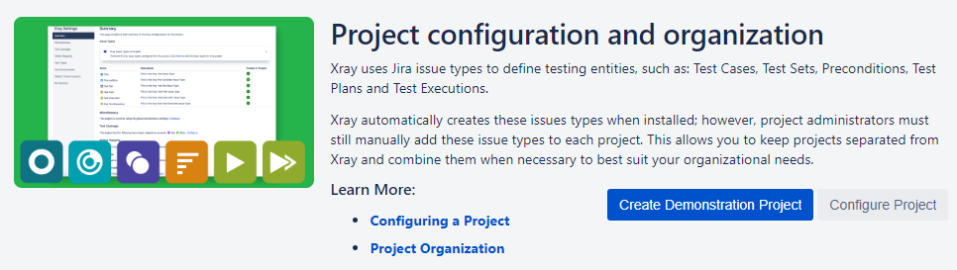
Select the project you are working on and select Configure. Next, you want to select “Add Xray Issue Types.”

Creating a Test Case
Previously, we only had 4 issue types in Jira: Epic, Story, Bug, and Task. Once Xray is added to your project you will have more issues added.
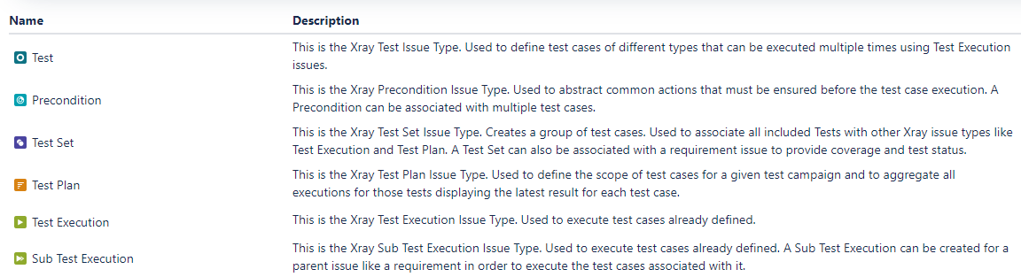
Now, when you are in Jira, you can select “Create” and you will see these issues added to the Issue Type dropdown.

Let’s create a Test Case.
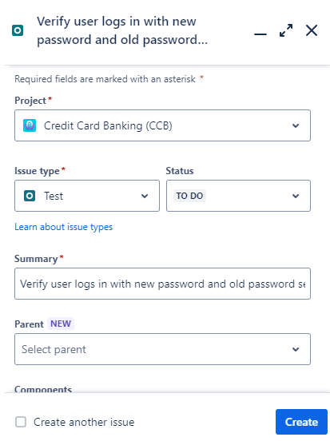
Now, once you create this, we can view this Test Case by selecting our Issues tab.
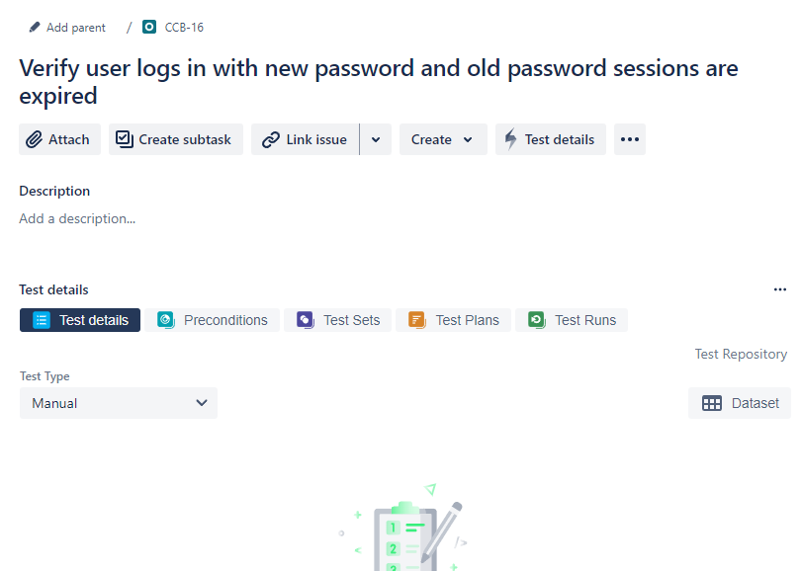
You will notice several tabs: Test Details, Preconditions, Test Sets, Test Plans, and Test Runs. I will review these in detail in the next steps.

Test Step
If we are on the Test Details tab, you will notice it states “There are no steps defined.”
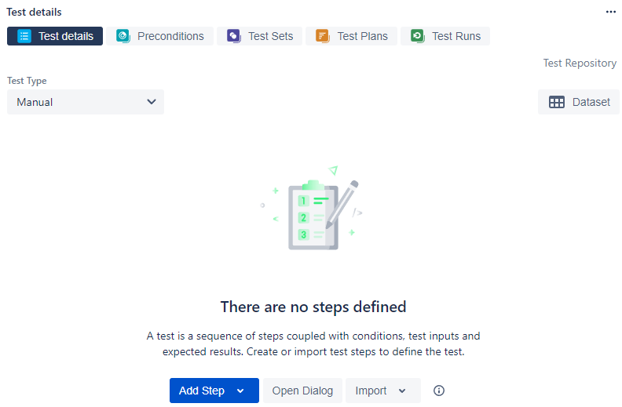
Test Steps are the sequence of events that are required for a Test Case to reach the desired outcome.
Let’s select Add Step and you will understand as we proceed. With each Step, you will have an Action followed by an Expected Result. In order to begin verifying if the user logs in with the old password, we need to first be on the Website domain page. This is our first Action, or step. The Expected Result would be the website page being displayed. Let’s add this as our first Action.
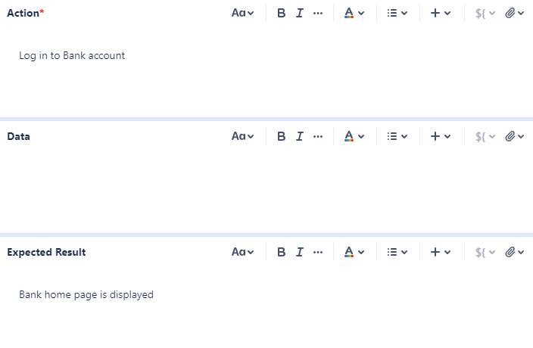
To log in to a bank account, there is specific Data that needs to be entered on the login page to achieve the expected result. However, not every scenario requires data.
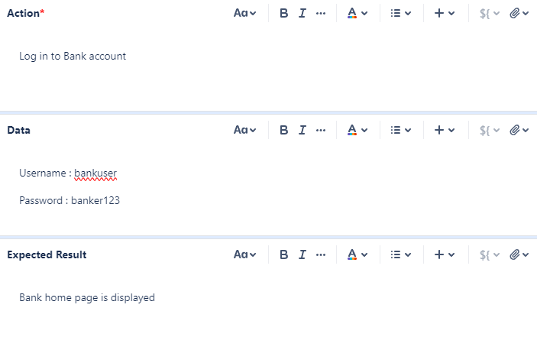
After selecting Create, you will see your new step displayed. You can add any attachments that might facilitate the process for the developer, such as an image of the expected outcome.
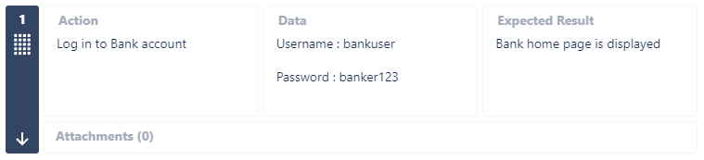
Let’s create more steps to fulfill our Test Case.
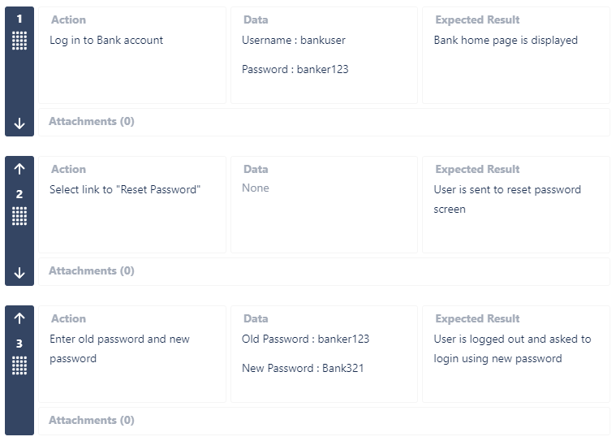

Preconditions
Preconditions are conditions that need to be met in order to execute a test.
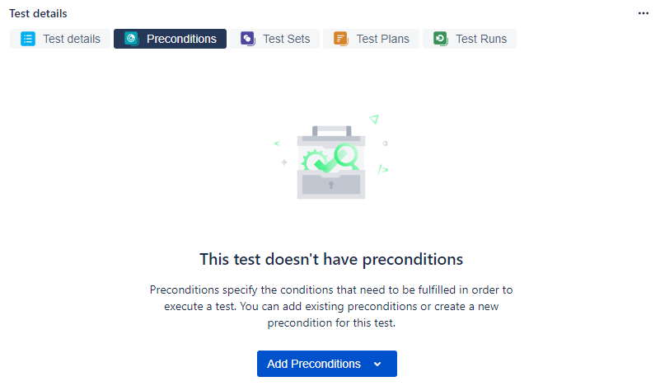
For example, if you want the user to reset the password, the precondition might be that the user needs to be on the Bank page and select the “Forgot Password” link. We can’t technically start our test case if we haven’t met our precondition.
Let’s create a precondition for the Test Cases we created.
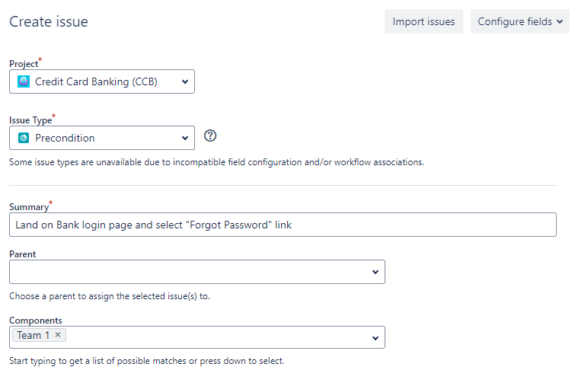
You can provide any details that you feel are needed to navigate to the Bank login page. So, before checking the Test Details and viewing the Test Steps, the developer needs to verify the Precondition first.

Test Sets
Test Sets are a collection of tests that are used to organize and group tests.
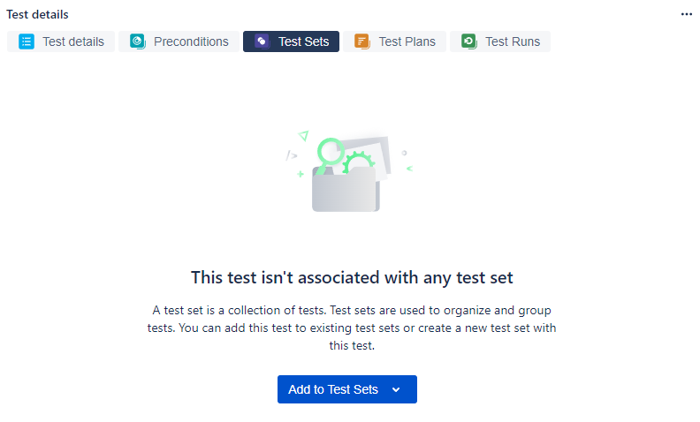
The test set might be an organized method that our individual teams can refer to for feasibility.
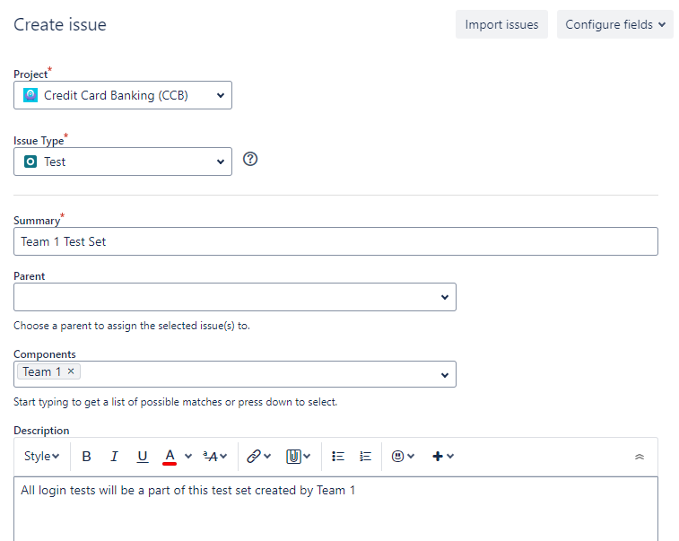
Now, once I hit Create, the Test Case is automatically linked to this Test Set. If we open our Test Set, you can view our Tests linked to this Set.
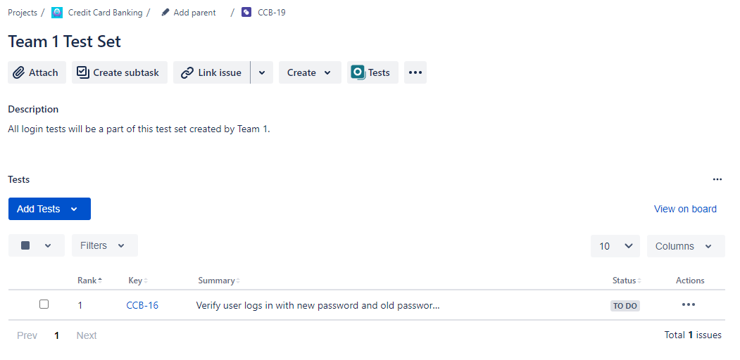
Now, we can link test cases to this test set and have our test cases organized in one location.
If we want to create more test cases and link them to this test set, we just have to go into our test set and add “Existing Test.”
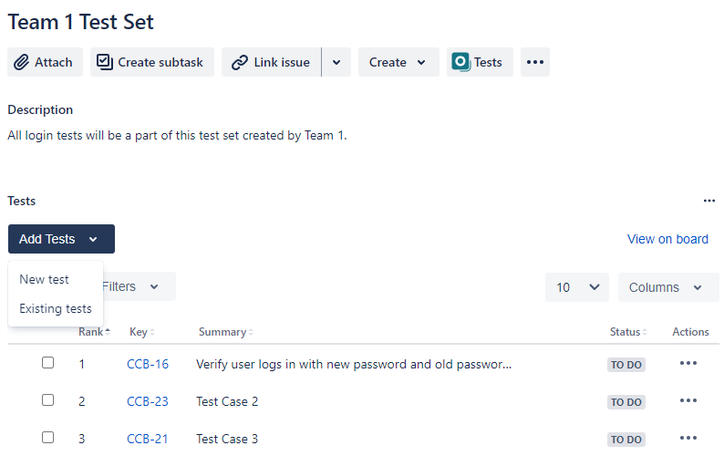
Then, we can search for any other test cases that have been created and add selected.


Test Plans
Since we are working in an agile methodology, we will use a test plan to help manage our test cases for a given scope.
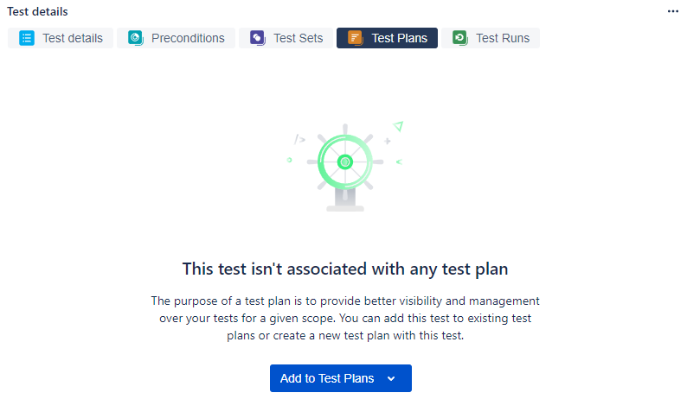
Let’s say I have 100 test cases to complete. I would use a test plan to break these into sprints and break these into 25 test case sprints.
I have skipped ahead and added a few dummy Test Cases that contain test steps and a precondition already.
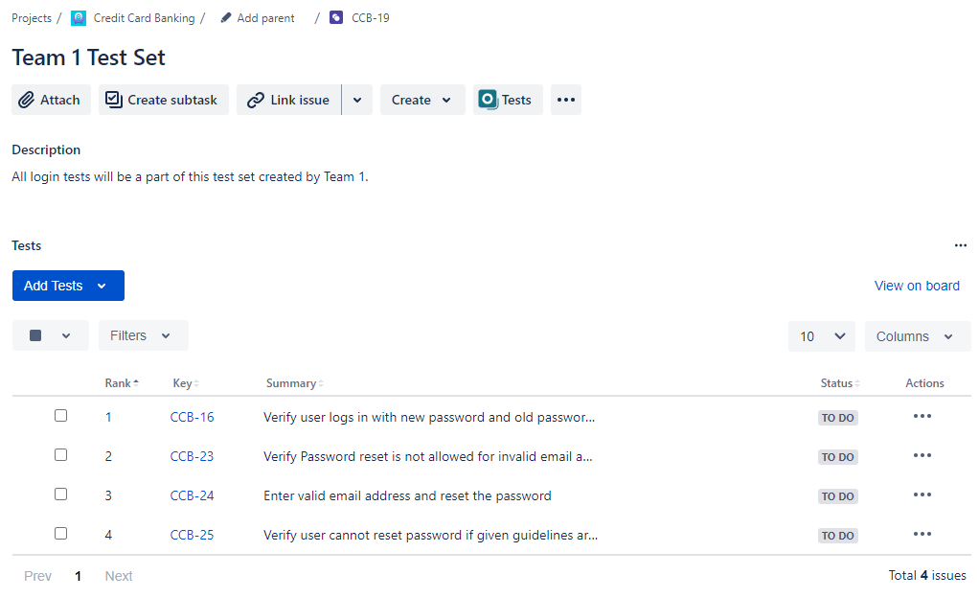
Let’s create our Test Plan. I want this Test Plan to be set for release on Jan. 26, so I can include this in my Test Plan name for easy visibility.
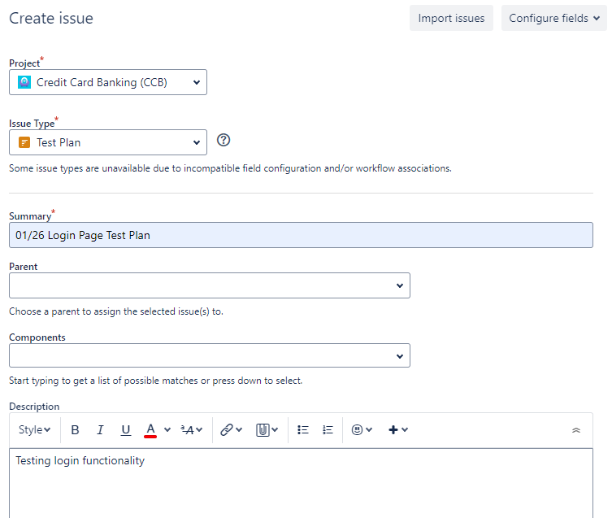
Once I create the Test Plan, I can Add Tests to it. Since I have some created already, I have selected Existing Tests and selected two. Then, you will be directed to this page below.
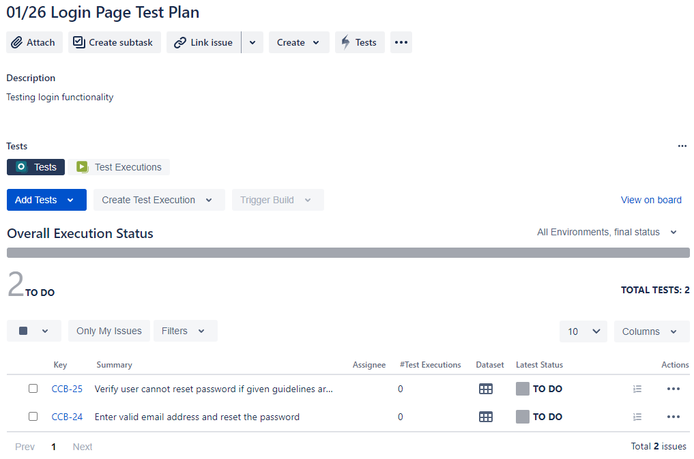
We can even add the entire set by selecting Tests from Test Sets.
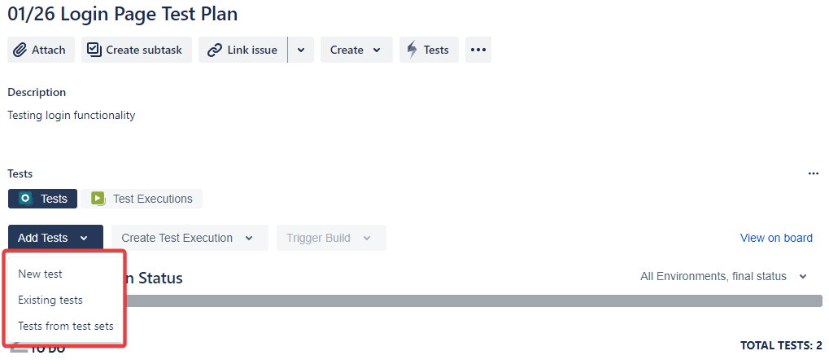
Next, we need to execute this test plan so our team can begin updating the test cases. We can do this by selecting Test Executions and “All Tests.” We can link it to our Fix Version.

The dates for the fix version and test plan are incorrect. Disregard dates
Now, we can begin our execution by selecting the Play Button:
That will take us to our steps page where we can individually create comments, defects, or evidence.
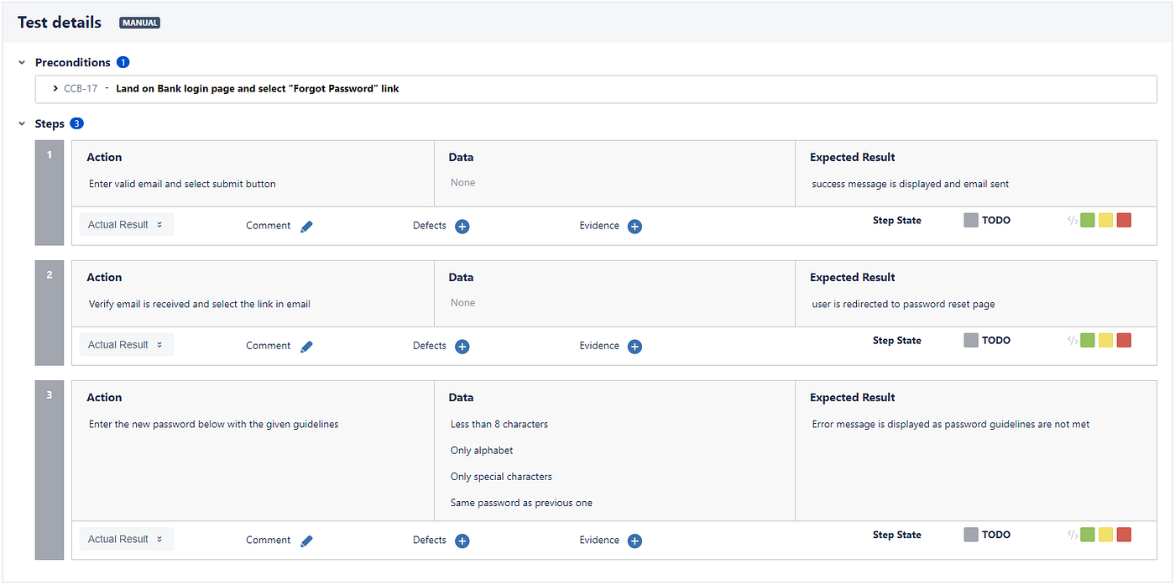
We can also mark our test case as a passed, failed, or still executing on our test plan page. This isn’t as detailed as marking the individual actions on the test step, but it is still a method of showing progress.

You can easily assign a person a specific test case by selecting the Actions button.
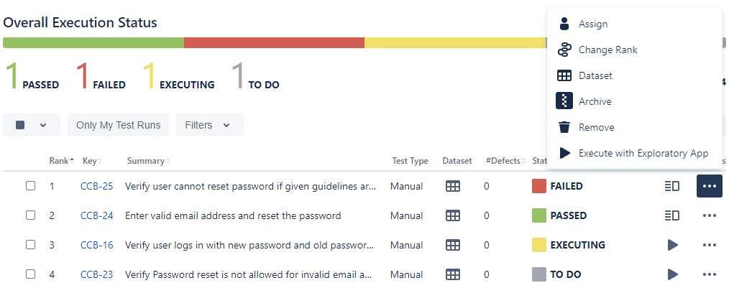
Now, if we return to our backlog, you will see that if we select our Test Execution, you can visualize the status on the right-hand side.
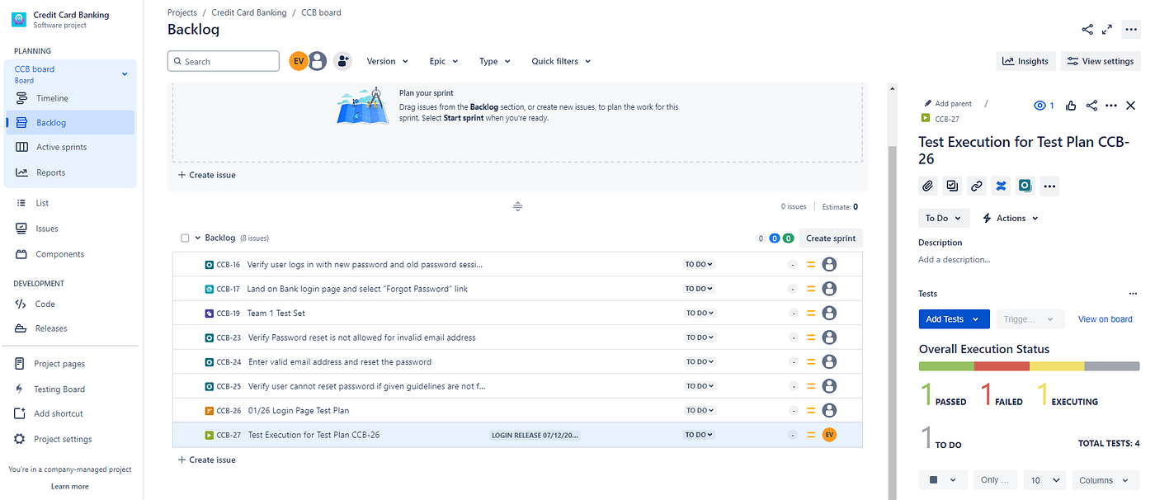
Now, if we select an individual test case, we can track the status and all of the info we have included for that specific test case. Here is a test case that is still in progress:


Test Plan vs. Test Execution
So, to help differentiate the two, a Test Plan outlines the overall approach and objectives for testing a specific component or feature. It serves as a blueprint or roadmap for the testing effort, guiding the team on how testing will be conducted. The Test Plan will have the Test Set within it, which is simply a collection of tests.
The Test Execution will be created from the Test Plan to be able to report the status of the test plan. It involves actually running the tests that are defined in the Test Plan. It provides concrete data on how well the software performs under various conditions and identifies any issues that need to be addressed.
In summary, the Test Plan sets the stage for testing by defining what needs to be tested and how, while Test Execution carries out those tests and records the outcomes. Both are essential phases in ensuring software quality and functionality.
Now, let’s say that the developer has completed a story or currently working on it. You can link a test case to this particular story to associate the two and see how that user story is being tested.

These are the vital features of Xray within Jira. It is a vital component of the testing phase within the development cycle.

